**PROJECT DESCRIPTION**

In my role as a data analyst at Udemy my team leader gave me the responsibility to present the data on courses income in order to comprehend and spot opportunities to boost revenue, keep track of how the various courses are performing and determine which course is the most liked overall.

Information needed will be provided with the use of data from the following topics: web development, graphic design, business finance, and musical instruments. To make the data easier to interpret, it is presented in descriptive, tabular, and visual forms.

The business challenge is to comprehend and evaluate the effectiveness of the various courses offered on the Udemy website, spot prospects for future income expansion, and pinpoint the most well-liked subject areas among subscribers.

To determine how each subject is performing, the study looks at the subject with the most subscribers overall, the subject with the highest price, and the subject with the most good reviews.

**DATA DESIGN**

I have researched prior trends in customer subscriptions from udemy across more than four (4) distinct academic areas. Using Google Sheets, the data was cleaned up, duplicates removed, blank cells removed, and inconsistent data corrected. Pivot charts and Tableau were used to evaluate the clean data and produce the required images.

The study's objectives are to pinpoint potential chances for revenue growth and monitor performance in the areas of web development, graphic design, business finance, and musical instruments.

The analysis revealed that WEB development outperformed the other topic areas in terms of income and performance. Tableau is better suited to managing massive data sets and can offer a highly in-depth analysis, thus I picked it for the data visualization.

**FINDINGS FROM THE DATA**

***Finding 1***

Table 1: Total subscription by subject

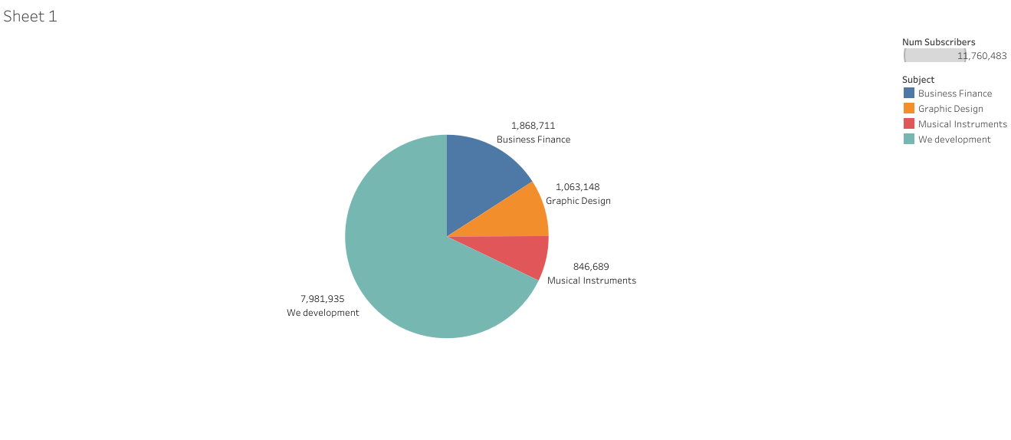

The data obtained from the various course title.The highest course enrolled for is web development numbering 7,981,935.

***Finding 2***

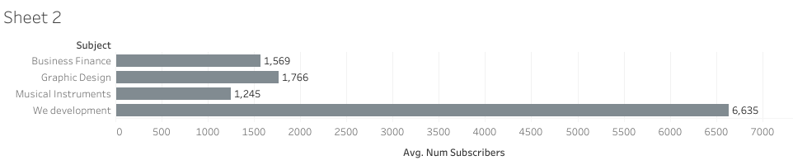

Web development has the highest number of reviews for each subject.

***Finding 3***

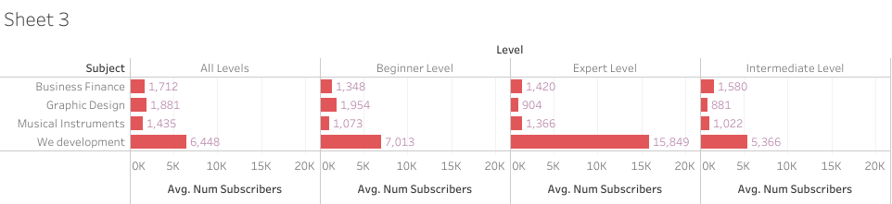

The table above shows the average cost price for each subject at various levels.

***Finding 4***

Web development tops with 5,587 as the average content duration, which is shown in the table.

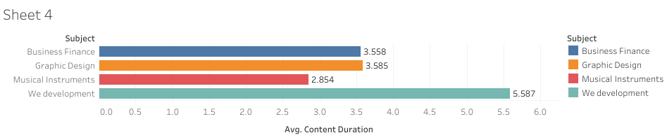

***Finding 5***

Graphics design tops for the average rating per subject at various levels ranging from all levels to expert level.

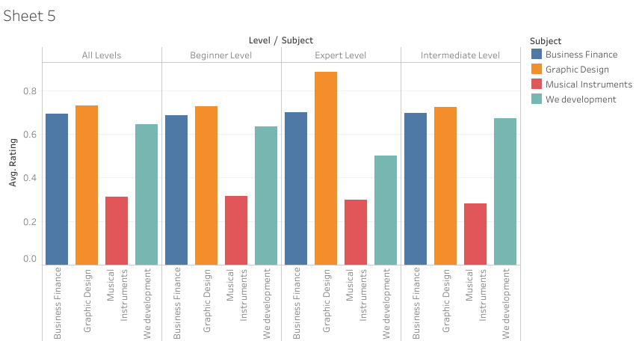

**ANALYSIS**

My initial interpretation of the data is that, among the several themes being taken into consideration, Web Development would have the biggest number of subscribers because, in my opinion, it is the most well-liked of all the subject areas.

The majority of the courses under Web Development are available for free, and the courses under Web Development have less reviews to entice subscribers to enroll in courses linked to Web Development, therefore my inferences include a potential drop in revenue.

Finding the fundamental cause of the problems that have been found and fixing them is the main goal of the five why analysis. The quantity of inquiries made made it possible to identify the underlying cause of the noted issue.

The analysis' findings revealed that there may be a chance to boost sales.

**WHY ANALYSIS**

PROBLEM: Reduction in sales

1: why?

Low number of subscribers

2: why?

Courses are too expensive

3: why?

Lack of high rating

4: why?

Courses content should be improved

**CONCLUSION**

It can be necessary to calculate the total profit in relation to the number of subscribers who have signed up for the various subjects.

Reviews from the various subscribers may help to enhance the content of web development courses and increase income.

The information supplied demonstrates that Web Development is the most well-liked and financially most lucrative subject.